JAVA NEW FEATURES
Functional vs OO Programming
Imperaive vs Declarative Programming
Lambda Expressions (Java 8)
Stream API (Java 8)

Interview Questions on Java New Features
- Lambda Expressions (Java 8)
- Stream API (Java 8)
- Optional (Java 8)
- Default Methods in Interfaces (Java 8)
- Method References (Java 8)
- Records (Java 14)
- Sealed Classes (Java 15)
- Module System (Java 9)
- String Methods (Java 11)
- G1 Garbage Collector (Java 9)

Interview Questions on Java 8 Features
- What is a functional interface in Java? Give an example.
  - Discuss how functional interfaces are used in Java 8, and how they enable lambda expressions.
- What are Lambda Expressions, and how do they improve code readability in Java?
  - Explain the syntax and use cases of lambdas in Java 8 and how they help in simplifying code.
- Explain the concept of Streams in Java 8. How does it differ from collections?
  - Discuss stream operations, pipelines, and the difference between stream and collection-based approaches.
- What is the purpose of the default keyword in Java 8 interfaces?
  - Describe how default methods allow the addition of new methods to interfaces without breaking the existing implementation.
- What is the Optional class in Java 8, and why is it useful?
  - Explain how Optional helps in avoiding NullPointerException by providing a container object which may or may not contain a non-null value.
- What are method references in Java 8? How are they used with streams?
  - Describe the syntax and practical applications of method references in the context of Java 8 streams.
- What are the differences between map() and flatMap() in Java 8 Streams?
  - Discuss the differences in their functionality, particularly how flatMap() works when dealing with nested collections.

Functional Programming | Object Oriented Programming
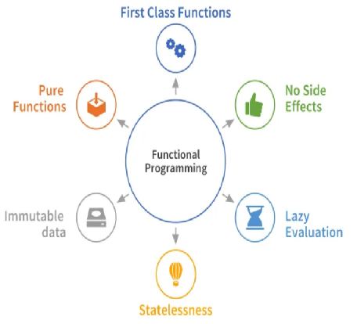 | 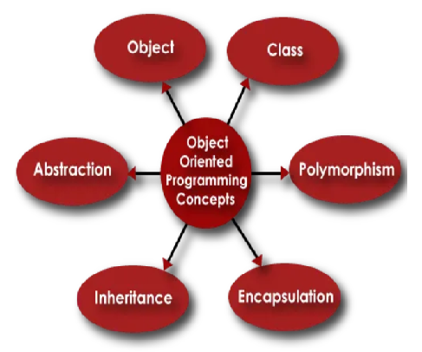
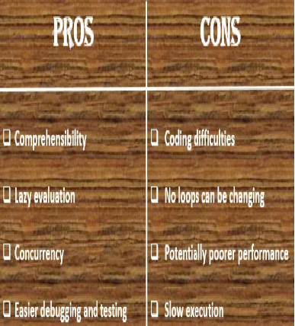 | 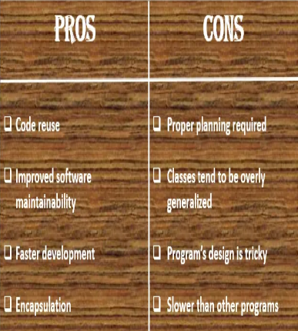
Scenario:-  import java.util.Arrays;  import java.util.List;  import java.util.stream.Collectors;  public class LazyEvaluationExample {  public static void main(String[] args) {  List<Integer> numbers = Arrays.asList(1, 2, 3, 4, 5, 6, 7, 8, 9, 10);  // Lazy operations: filter and map won't execute until collect is called  List<Integer> result = numbers.stream()  .filter(n -> {  System.out.println("Filtering: " + n);  return n % 2 == 0;  })  .map(n -> {  System.out.println("Mapping: " + n);  return n;  })  .limit(2)  .collect(Collectors.toList()); // Terminal operation  System.out.println("Result: " + result);  }  }  • filter and map are intermediate operations that are lazily evaluated.  • The results are calculated lazily, and intermediate operations won’t be executed until the terminal operation, collect(), is called.  • Potential for early termination (e.g., limit()) | Scenario:-  import java.util.ArrayList;  import java.util.Arrays;  import java.util.List;  public class EarlyEvaluationExample {  public static void main(String[] args) {  List<Integer> numbers = Arrays.asList(1, 2, 3, 4, 5, 6, 7, 8, 9, 10);  // Early evaluation: Filter and map are executed immediately  List<Integer> result = new ArrayList<>();  // Loop through each element and filter + map immediately  for (Integer n : numbers) {  System.out.println("Filtering: " + n); // Filtering step  // Filtering step (only even numbers)  if (n % 2 == 0) {  System.out.println("Mapping: " + n); // Mapping step  result.add(n * 2); // Add the mapped value to the result list  }  }  // Print the final result  System.out.println("Result: " + result);  }  }  • Both filtering and mapping happen immediately for each element(eagerly evaluated)  • The results are calculated eagerly, and the elements are processed as they are encountered in the loop.  • Processes all elements without early termination

Java stream API defines functional-style operations on discrete sequence of data elements. (processing sequences of elements).

Streams are functional, they operate on the provided source and produce results rather than modifying the source.

Streams can be created from different element sources e.g. collections or arrays with the help of stream() and of() methods

String[] arr = new String[]{"a", "b", "c"};

Stream<String> stream = Arrays.stream(arr);
stream = Stream.of("a", "b", "c");

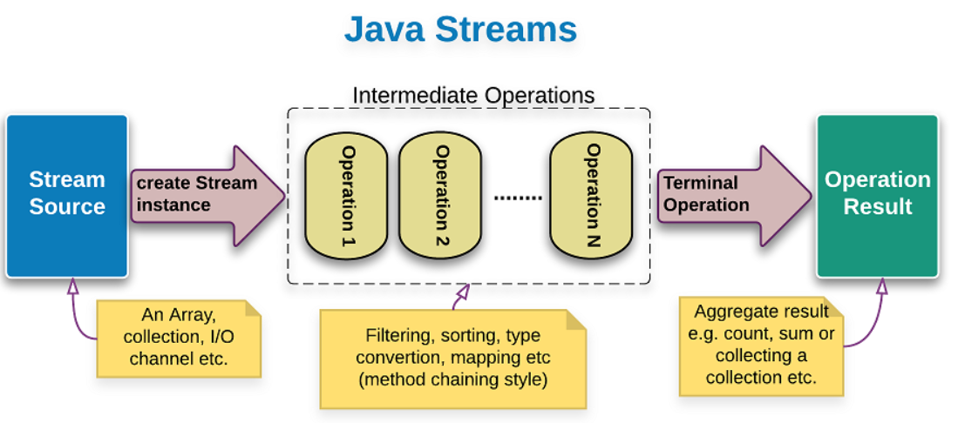
Stream operations are divided into
1) Intermediate operations (return Stream<T>) like filter(), map(), and sorted()
2)Terminal operations (return a result of definite type) like forEach(),count(), max(..), toArray(..), collect(..)

Ex:-
List<Integer> list = Arrays.asList(1, 2, 3, 2, 4);
long count = list.stream().distinct().count();

the distinct() method represents an intermediate operation, which creates a new stream of unique elements of the previous stream. And the count() method is a terminal operation, which returns stream’s size.

The new Stream class provides a forEach() method, which can be used to loop over all or selected elements of the list and map. The forEach() method provides several advantages over the traditional for loop e.g. you can execute it in parallel by just using a parallel Stream instead of a regular stream.

List<Integer> list = Arrays.asList(1, 2, 3, 2, 4,5);
long count = list.stream().distinct().count();
System.out.println(count);

//lambda expression
list.stream().forEach(e->System.out.println(e));
//lambda expression using method inference
list.stream().forEach(System.out::println);

Examples
Old Imperative Style | New Declarative Style
we have to write code line by line to give instructions to the computer about what we want to do to achieve a result | we just have to focus on what we want to achieve without repeating the low level logic (like looping) every time. Stream API achieve this by using internal iterator constructs along with lambda expressions.
Internal iteration, using new default method Iterable#forEach(Consumer<? super T> action)
List<String> list =  Arrays.asList("Apple", "Orange", "Banana");  for (String s : list) {  System.out.println(s);  } | List<String> list =  Arrays.asList("Apple", "Orange", "Banana");  //using lambda expression  list.forEach(s -> System.out.println(s));  //or using method reference on System.out instance  list.forEach(System.out::println);
Counting even numbers in a list, using Collection#stream() and java.util.stream.Stream
List<Integer> list =  Arrays.asList(3, 2, 12, 5, 6, 11, 13);  int count = 0;  for (Integer i : list) {  if (i % 2 == 0) {  count++;  }  }  System.out.println(count); | List<Integer> list =  Arrays.asList(3, 2, 12, 5, 6, 11, 13);  long count = list.stream()  .filter(i -> i % 2 == 0)  .count();  System.out.println(count);
Retrieving even number list
List<Integer> list =  Arrays.asList(3, 2, 12, 5, 6, 11, 13);  List<Integer> evenList = new ArrayList<>();  for (Integer i : list) {  if (i % 2 == 0) {  evenList.add(i);  }  }  System.out.println(evenList); | List<Integer> list =  Arrays.asList(3, 2, 12, 5, 6, 11, 13);  List<Integer> evenList =  list.stream()  .filter(i -> i % 2 == 0)  .collect(Collectors.toList());  System.out.println(evenList);  Or if we are only interested in printing:  List<Integer> list =  Arrays.asList(3, 2, 12, 5, 6, 11, 13);  list.stream().filter(i -> i % 2 == 0)  .forEach(System.out::println);
Finding sum of all even numbers
List<Integer> list =  Arrays.asList(3, 2, 12, 5, 6, 11, 13);  int sum = 0;  for (Integer i : list) {  if (i % 2 == 0) {  sum += i;  }  }  System.out.println(sum); | List<Integer> list =  Arrays.asList(3, 2, 12, 5, 6, 11, 13);  int sum = list.stream()  .filter(i -> i % 2 == 0)  .mapToInt(Integer::intValue)  .sum();  System.out.println(sum);  Alternatively  List<Integer> list =  Arrays.asList(3, 2, 12, 5, 6, 11, 13);  int sum = list.stream()  .filter(i -> i % 2 == 0)  .reduce(0, (i, c) -> i + c);  System.out.println(sum);
Finding whether all integers are less than 10 in the list
List<Integer> list =  Arrays.asList(3, 2, 12, 5, 6, 11, 13);  boolean b = true;  for (Integer i : list) {  if (i >= 10) {  b = false;  break;  }  }  System.out.println(b); | List<Integer> list =  Arrays.asList(3, 2, 12, 5, 6, 11, 13);  boolean b = list.stream()  .allMatch(i -> i < 10);  System.out.println(b);  Also look at Stream#anyMatch(...) method
Finding all sub-directory names in a directory. Using new static methods, Arrays#stream(T[] array)
List<String> allDirNames = new ArrayList<>();  for (File file : new File("d:\\").listFiles()) {  if(file.isDirectory()){  allDirNames.add(file.getName());  }  }  System.out.println(allDirNames); | List<String> allDirNames =  Arrays.stream(new File("d:\\")  .listFiles())  .filter(File::isDirectory)  .map(File::getName)  .collect(Collectors.toList());  System.out.println(allDirNames);

Stream Operations Examples:-

Creating Streams :
List<String> myList = Arrays.asList("apple", "banana", "orange");
Stream<String> sequentialStream = myList.stream();
Stream<String> parallelStream = myList.parallelStream();

Creates a stream from an array :
int[] numbers = {1, 2, 3, 4, 5};
IntStream stream = Arrays.stream(numbers);
Stream.of() method creates a stream from individual values.
Stream<String> stream = Stream.of("apple", "banana", "orange");

Intermeditate operations :
filter(): Filters elements based on a predicate.
List<String> filtered = myList.stream()
.filter(s -> s.startsWith("a"))
.collect(Collectors.toList());
//filter the items startswith a
map(): Transforms elements using a function.
List<Integer> lengths = myList.stream()
.map(String::length)
.collect(Collectors.toList());

sorted(): Sorts elements.
List<String> sorted = myList.stream()
.sorted() // we can use comparator here as a arg
.collect(Collectors.toList());

distinct(): Removes duplicate elements.
List<String> distinct = myList.stream()
.distinct()
.collect(Collectors.toList());

other operations are there like limit(), skip().

some terminal operations -
forEach(): Performs an action for each element.
myList.stream().forEach(System.out::println);
collect(): Accumulates elements into a collection.
List<String> collected = myList.stream()
.collect(Collectors.toList());

count(): Returns the number of elements.
long count = myList.stream().count();
Some more operations are ther anyMatch(), allMatch(), noneMatch() ,findFirst(), findAny() ,reduce().

Additional Operations we will see below :
flatMap() : Transforms each element into a stream of elements and then flattens these streams into a single stream.
List<List<Integer>> nestedList = Arrays.asList(
Arrays.asList(1, 2),
Arrays.asList(3, 4),
Arrays.asList(5, 6)
);
List<Integer> flattenedList = nestedList.stream()
.flatMap(List::stream)
.collect(Collectors.toList());

Collectors.groupingBy(): Groups elements based on a classifier function.
Collectors.partitioningBy(): Partitions elements into two groups based on a predicate.
Map<Integer, List<String>> groupedByLength = myList.stream()
.collect(Collectors.groupingBy(String::length));
Map<Boolean, List<String>> partitioned = myList.stream()
.collect(Collectors.partitioningBy(s -> s.length() > 4));

Stream.concat(): Concatenates two streams.
Stream<String> stream1 = Stream.of("apple", "banana");
Stream<String> stream2 = Stream.of("orange", "kiwi");
Stream<String> combinedStream = Stream.concat(stream1, stream2);

Java 8 introduced specialized streams for primitive types to avoid boxing/unboxing overhead.
IntStream intStream = IntStream.range(1, 5);
DoubleStream doubleStream = DoubleStream.of(1.0, 2.0, 3.0);

Lambda Expression was first introduced in Java 8 as a powerful new feature that allows developers to write short, anonymous functions that replace more verbose function definitions.

Lambda expressions consist of 3 parts:
- the parameter list,
- an arrow (->) and
- a body, which can be an expression or a block of code.

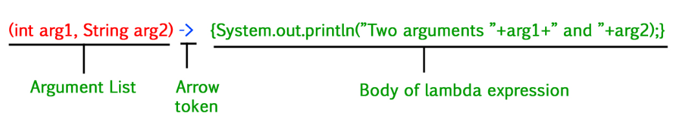

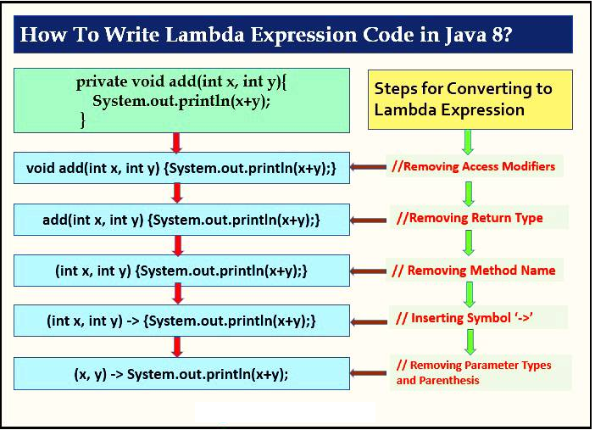

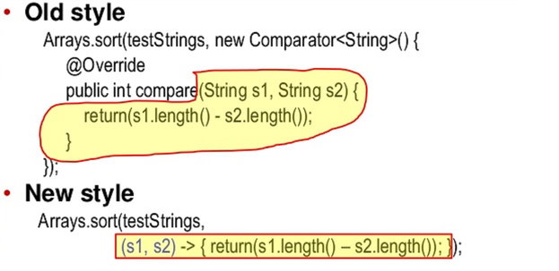

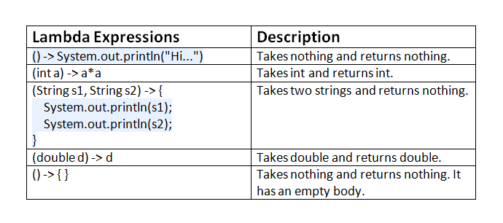

Functional interfaces and type inference are two essential concepts in Java that work together to enable lambda expressions.

Functional interfaces, are interfaces that have a single abstract method.

Type inference is a feature in Java that allows the compiler to infer the type of a lambda expression’s parameters. This means that the developer does not have to specify the type of the parameter explicitly.

Example:-
@FunctionalInterface
interface MyInterface {
int doSomething(int x, int y);
}

public class Demo {
public static void main(String[] args) {
MyInterface myLambda = (x, y) -> x + y; //function definition
Using lambda exp
int result = myLambda.doSomething(3, 5);//
System.out.println(result); // Output: 8
}
}

Notice that the types of the parameters are not specified in the lambda expression because type inference is used to determine their types.

By passing a function as an argument to another function, they allow you to write code that is more modular and reusable, enabling better separation of concerns and more efficient development.

Real Time Scenario

# Streams in a Grocery store
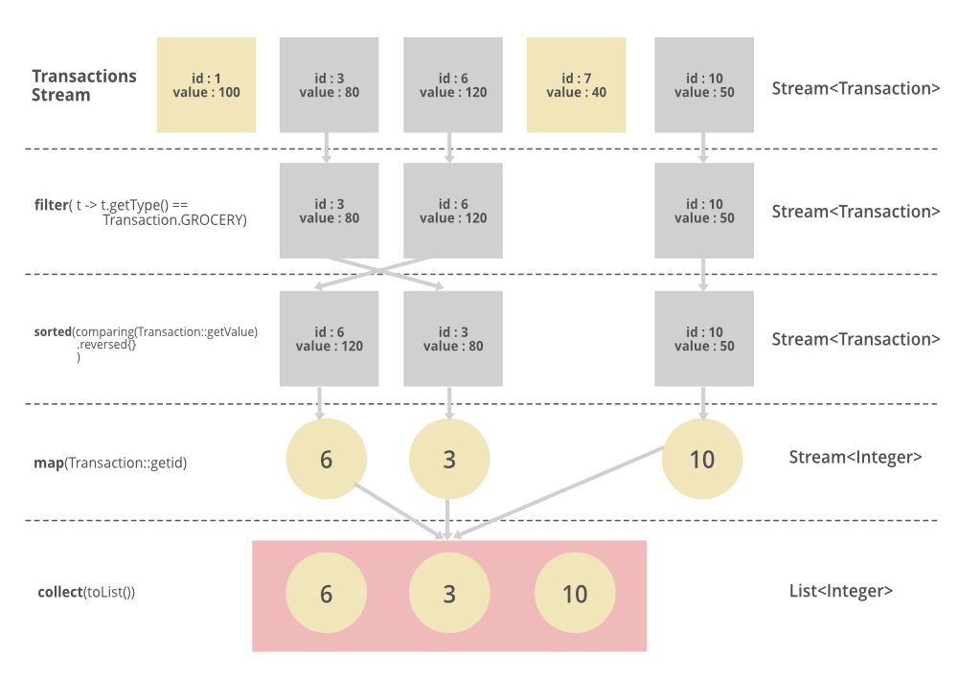

import java.util.*;
import java.util.stream.*;
import static java.util.Comparator.comparing;

public class Main {

// Transaction class to represent a transaction
static class Transaction {
static final String GROCERY = "GROCERY";
private int id;
private String type;
private double value;

// Constructor
public Transaction(int id, String type, double value) {
this.id = id;
this.type = type;
this.value = value;
}

// Getter methods
public int getId() {
return id;
}

public String getType() {
return type;
}

public double getValue() {
return value;
}
}

public static void main(String[] args) {
// Create a list of transactions
List<Transaction> transactions = Arrays.asList(
new Transaction(1, "GROCERY", 50.0),
new Transaction(2, "GROCERY", 20.0),
new Transaction(3, "ENTERTAINMENT", 100.0),
new Transaction(4, "GROCERY", 30.0),
new Transaction(5, "GROCERY", 70.0)
);

// Get the list of transaction IDs for GROCERY type, sorted by value in descending order
List<Integer> transactionIds = transactions.stream()
.filter(t -> t.getType().equals(Transaction.GROCERY)) // Filter by GROCERY type
.sorted(comparing(Transaction::getValue).reversed()) // Sort by value in descending order
.map(Transaction::getId) // Map to transaction IDs
.collect(Collectors.toList()); // Collect into a list

// Print the result
System.out.println("Sorted transaction IDs (GROCERY): " + transactionIds);
}
}

